1. Use the Route 53 Hosted Zone created in the Assignment.

Created domain “topcloth” got created.

* Created Route 53 hosted zone.

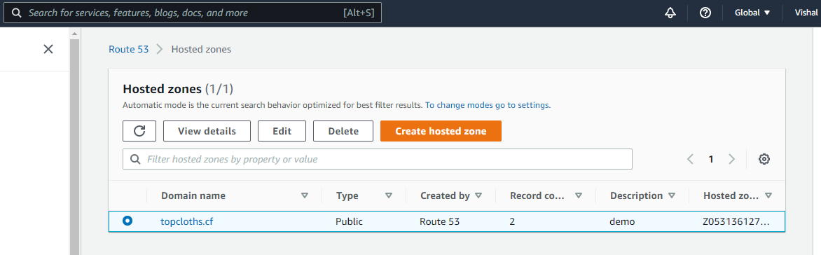

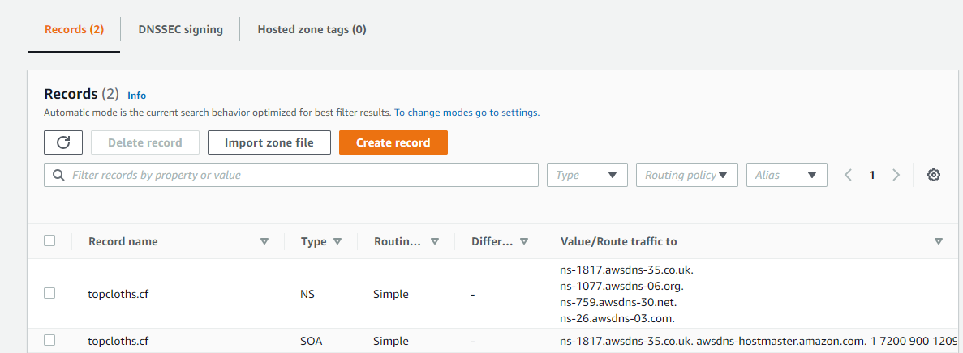

2.Route the traffic to an EC2 instance with an Apache web server running in it

using it’s IP address.

• I added two records with record names topcloths.cf, [www.topcloths.cf](http://www.topcloths.cf) and linked with the IP

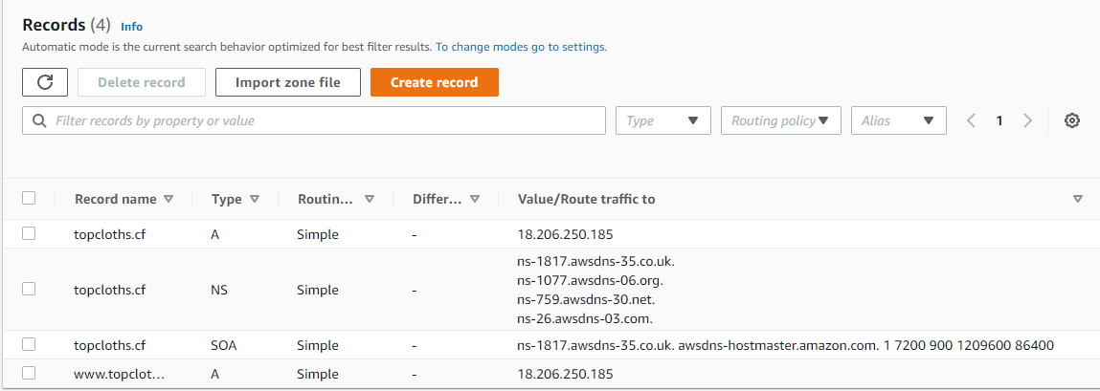

• Verifying domain name.

